**Practical No. 5**

1. **Using Packet Tracer, create a network with three routers with RIPv1 and each router associated network will have minimum three PC. Show Connectivity.**

**Step 1: Take 9 PCs**

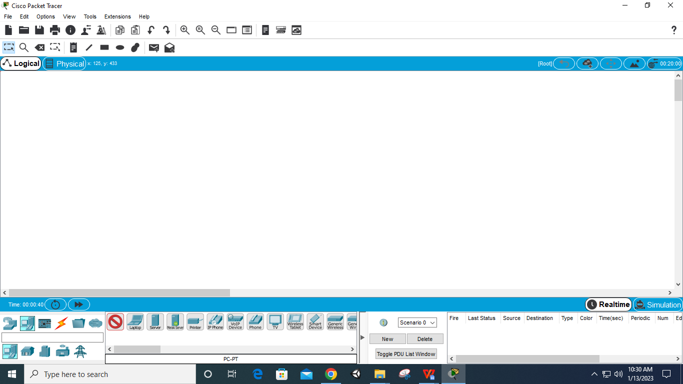

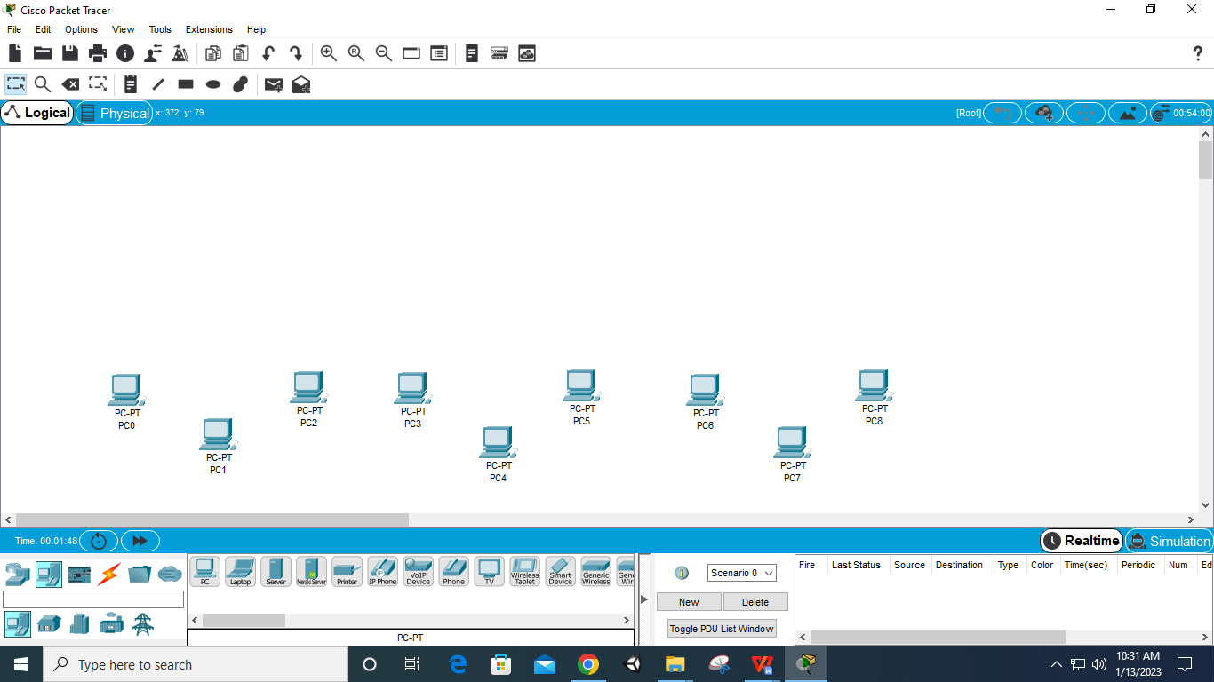

**Step 2: Take 3 Switches of name 2960**

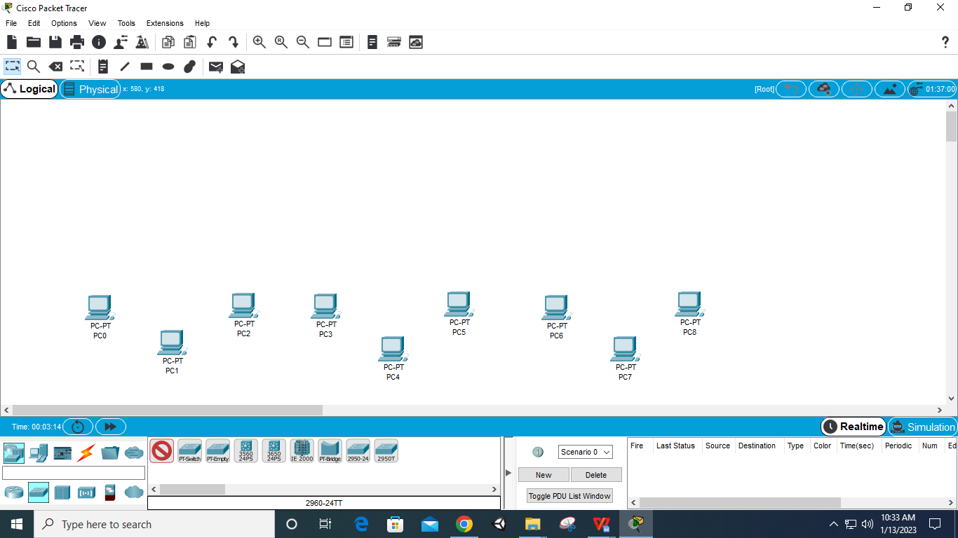

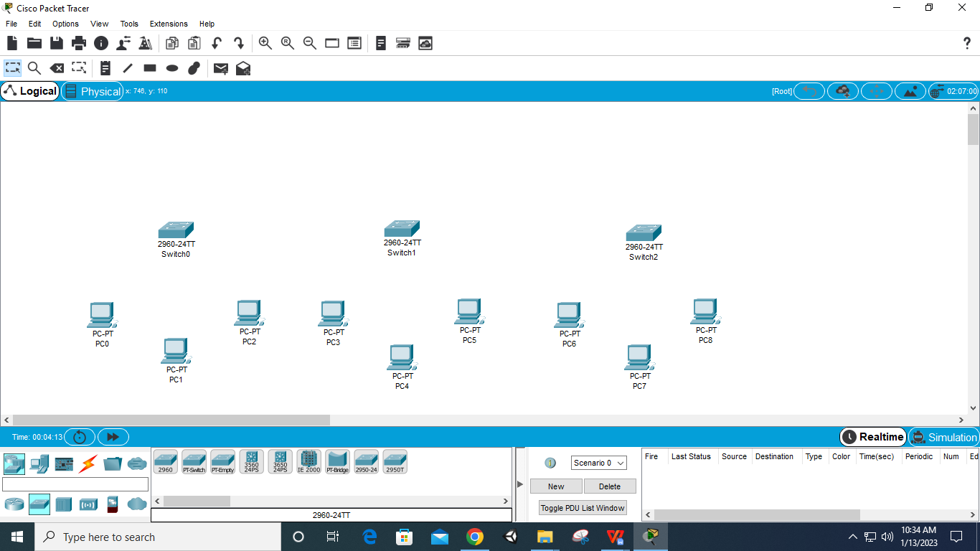

**Step 3: Take 3 routers of name 1841**

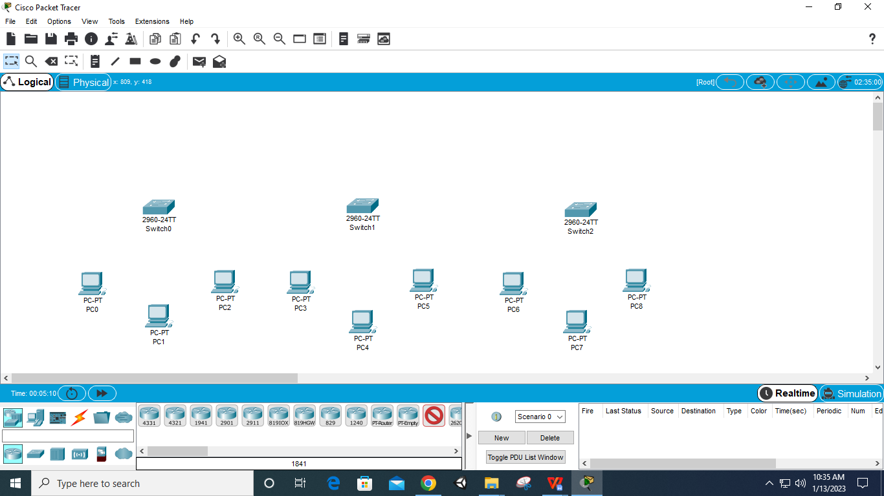

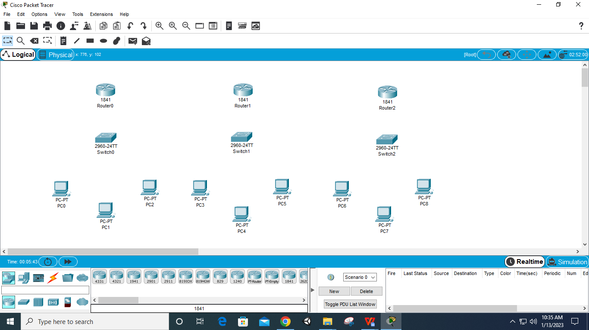

**Step 4: Connect PC to Switch through Copper Straight-**

**Through**

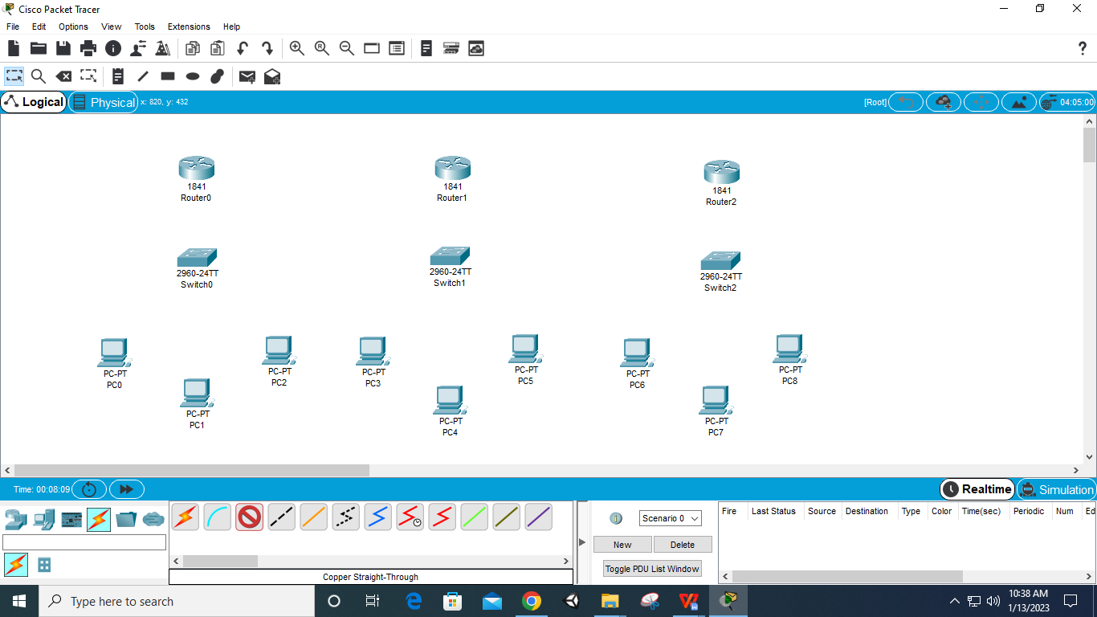

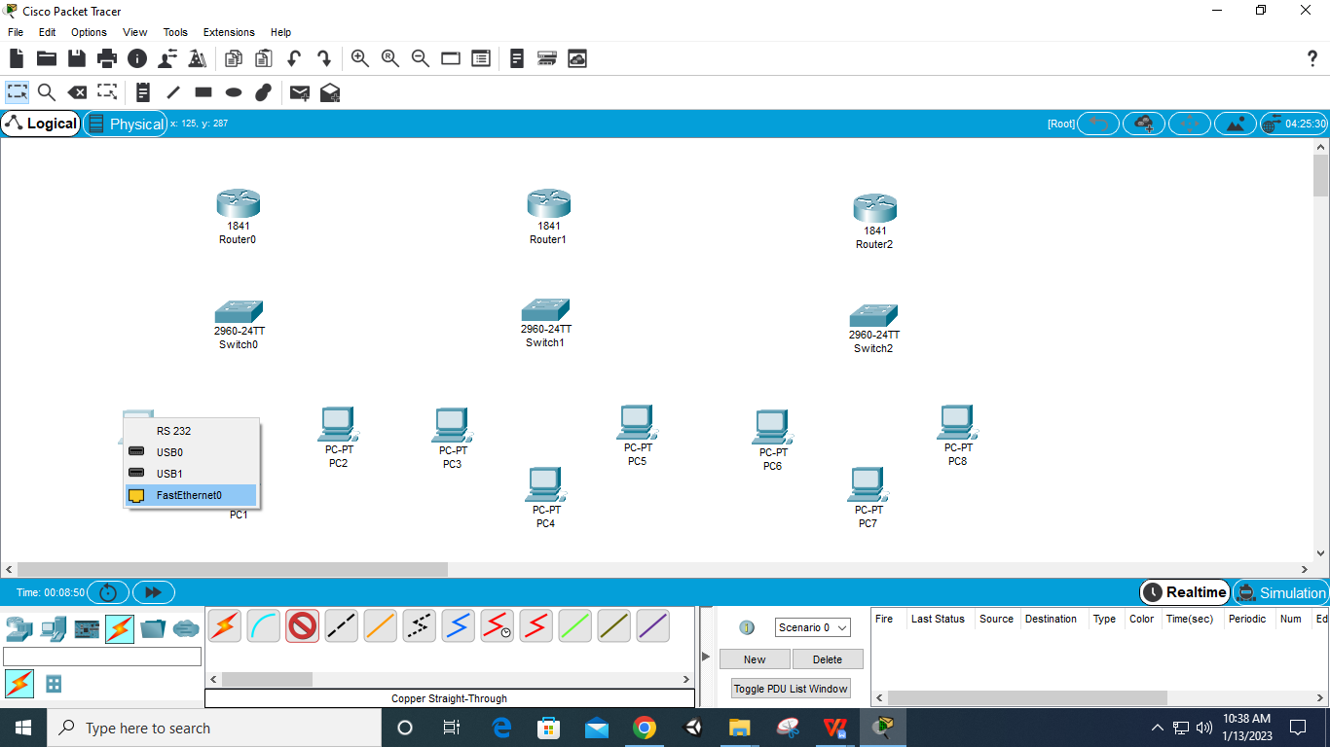

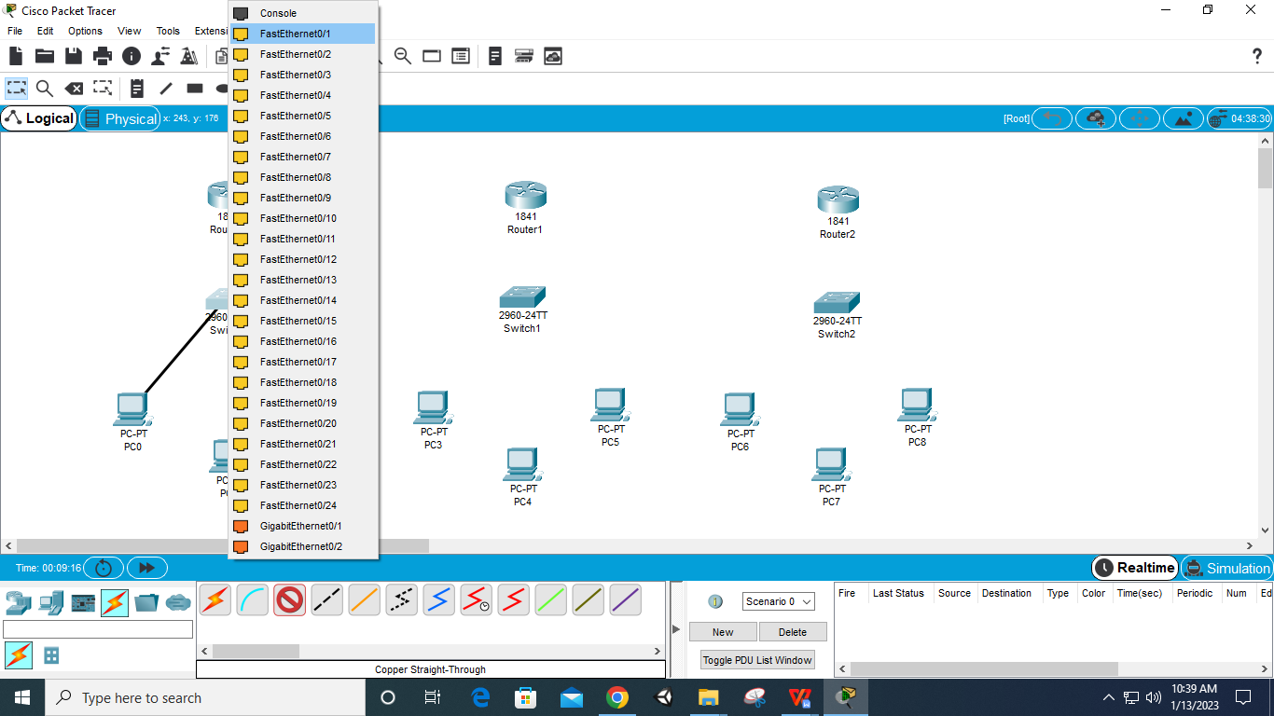

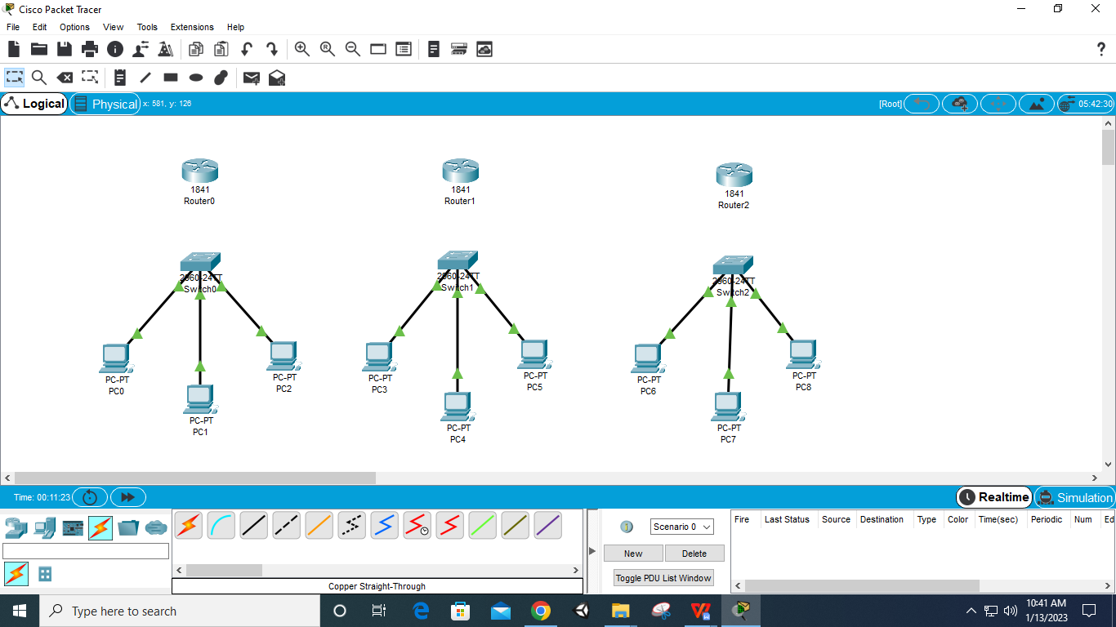

**Step 5: Connect Router and Switch using Copper Straight-Through with FastEthernet 0/0**

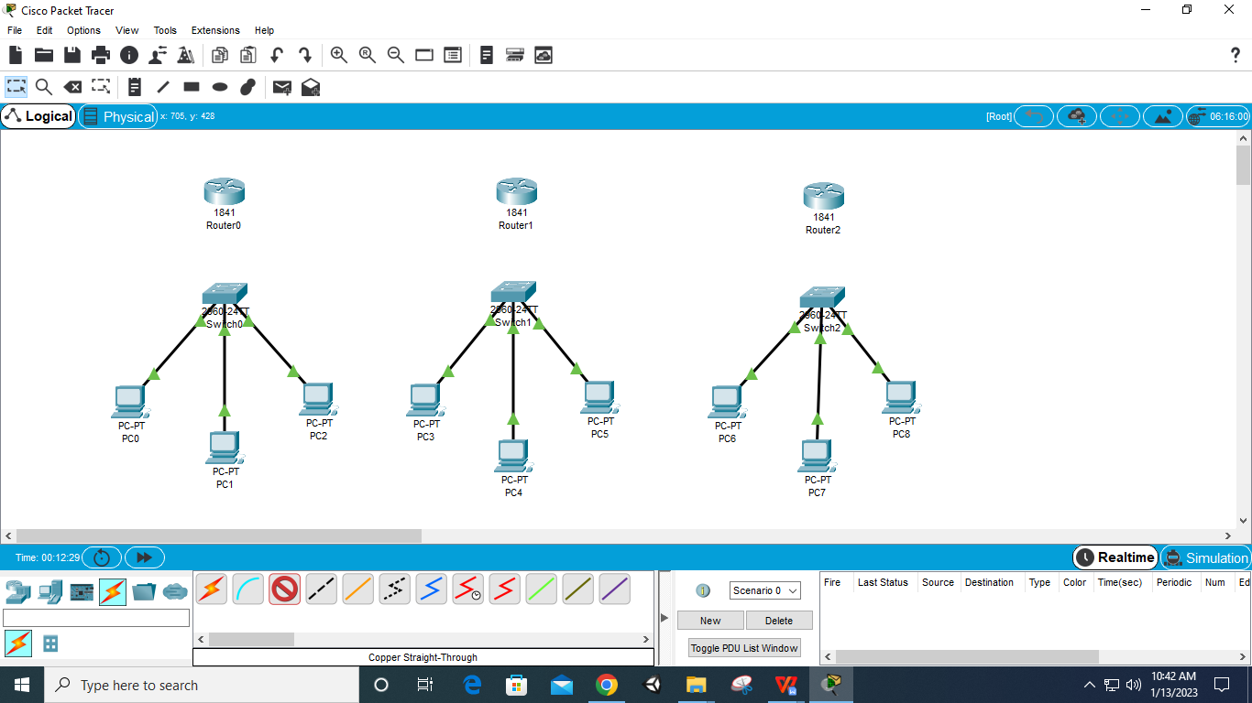

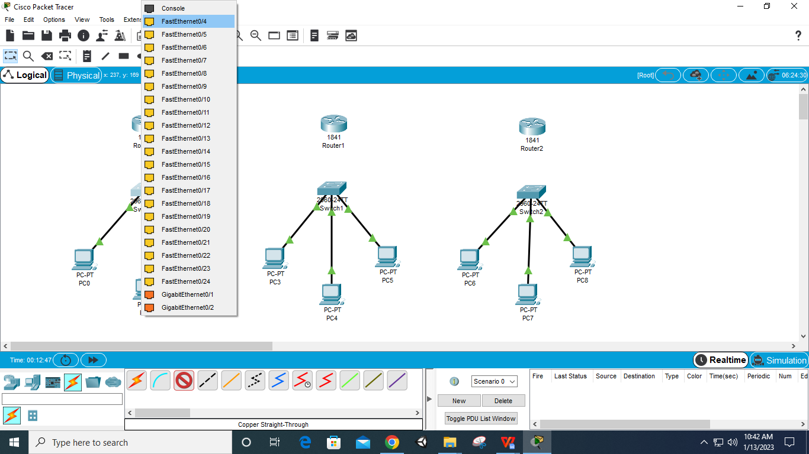

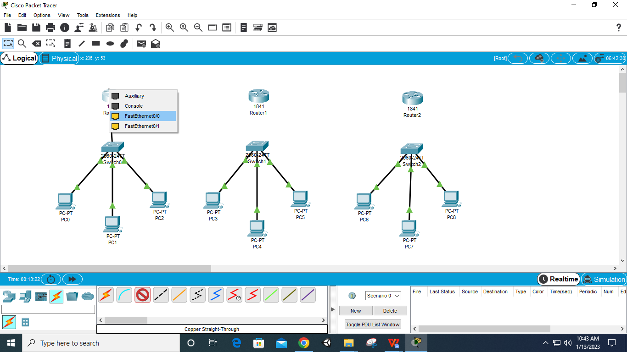

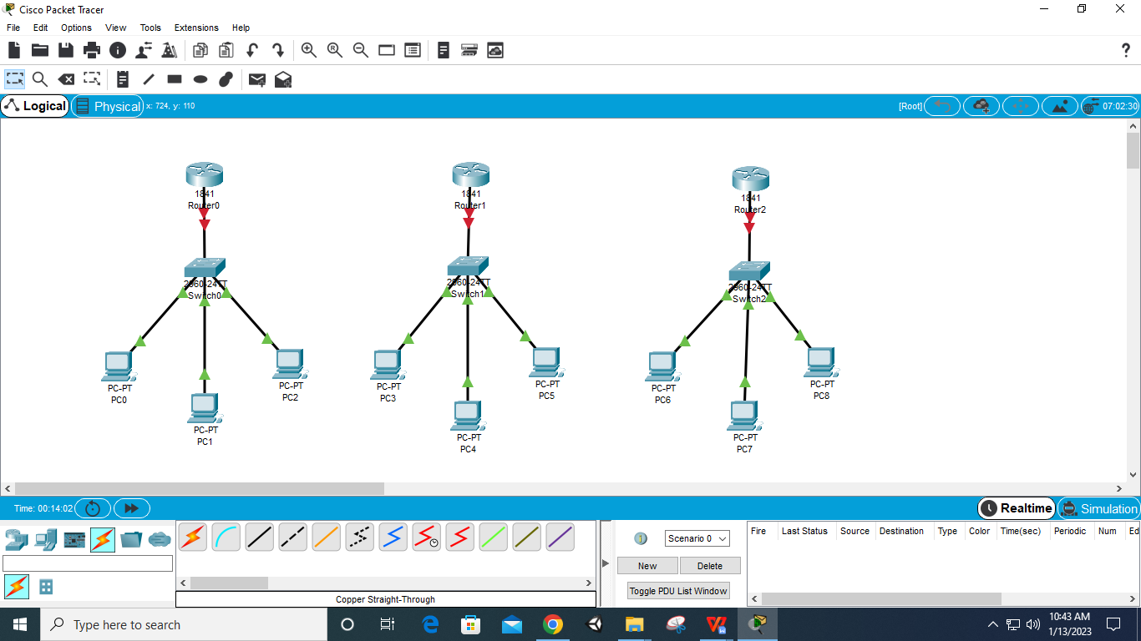

**Step 6: Select Router – Physical – WIC 2T – off Router – add Port – on Router (for all 3 Routers)**

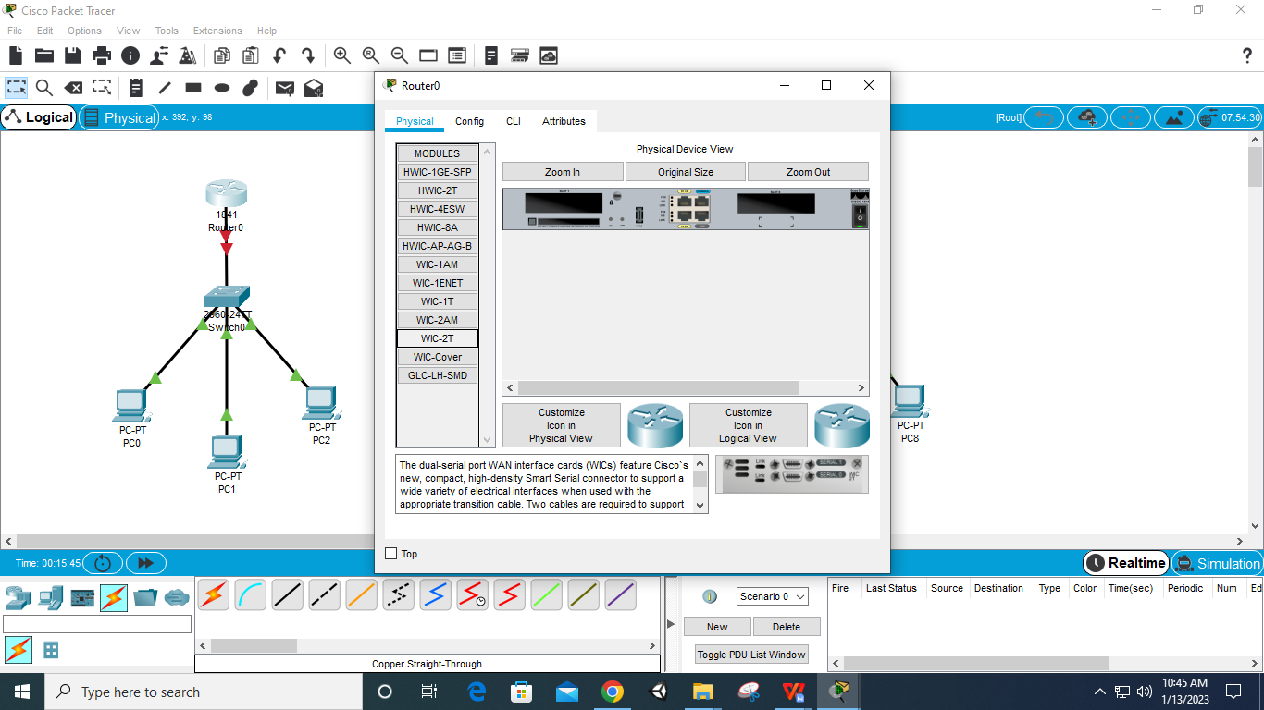

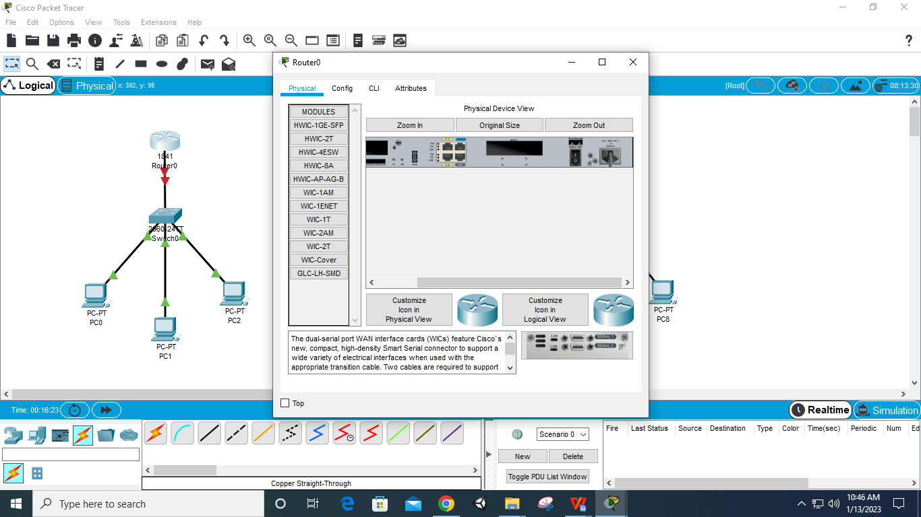

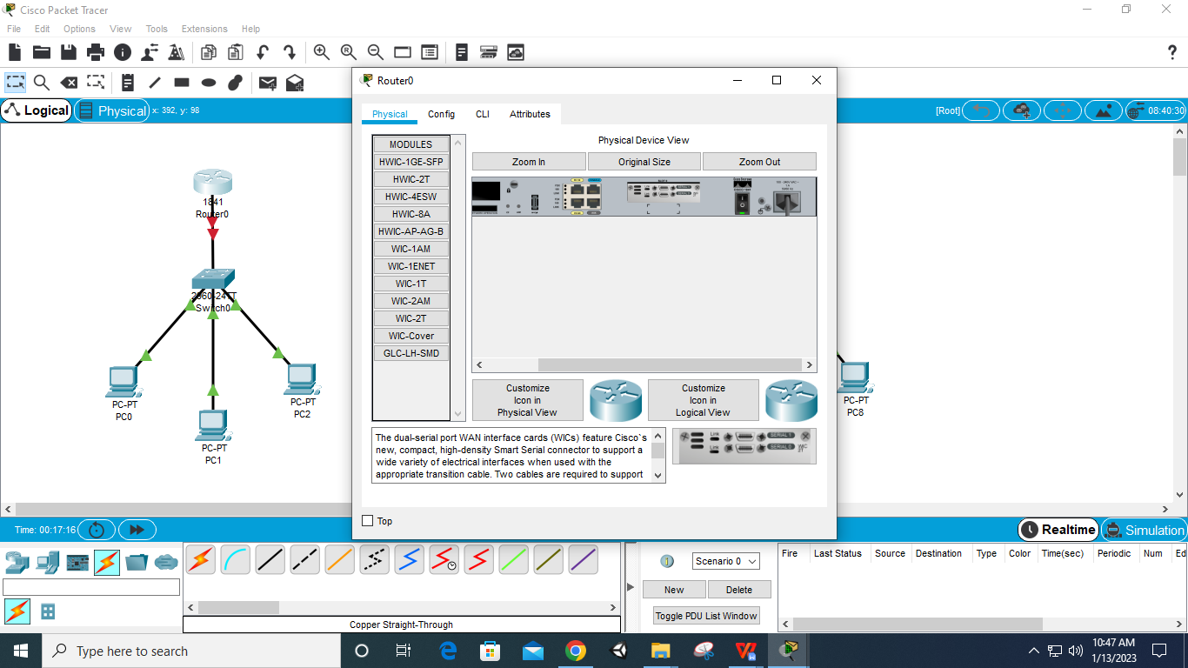

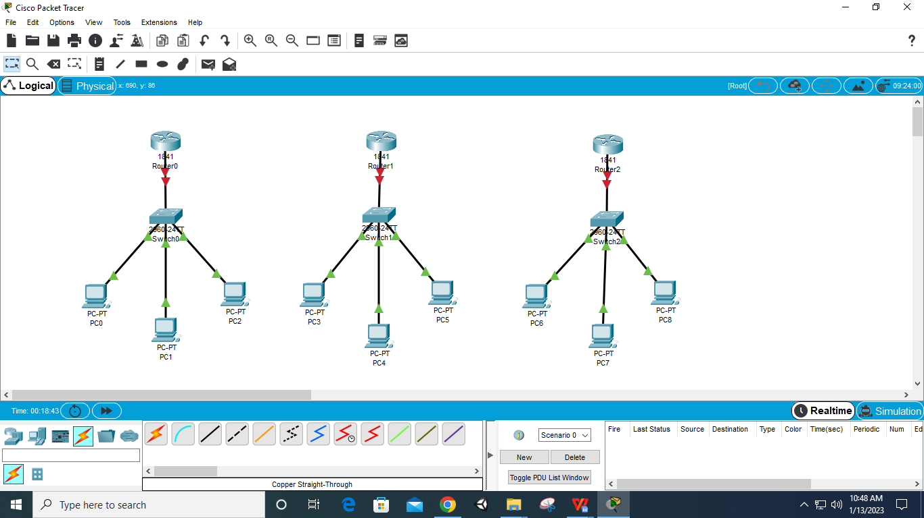

**Step 7: Connect Routers using Serial DTE wire – to Serial Ports**

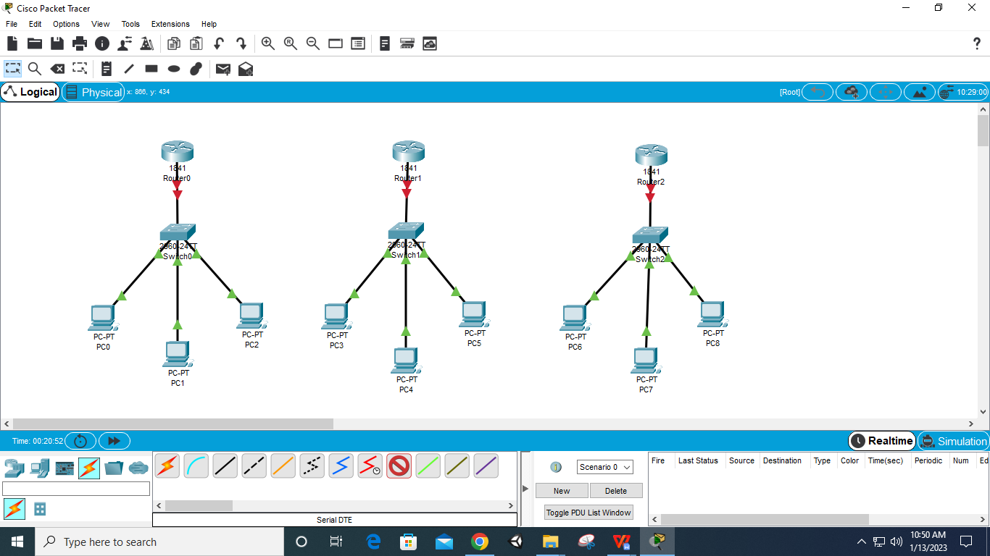

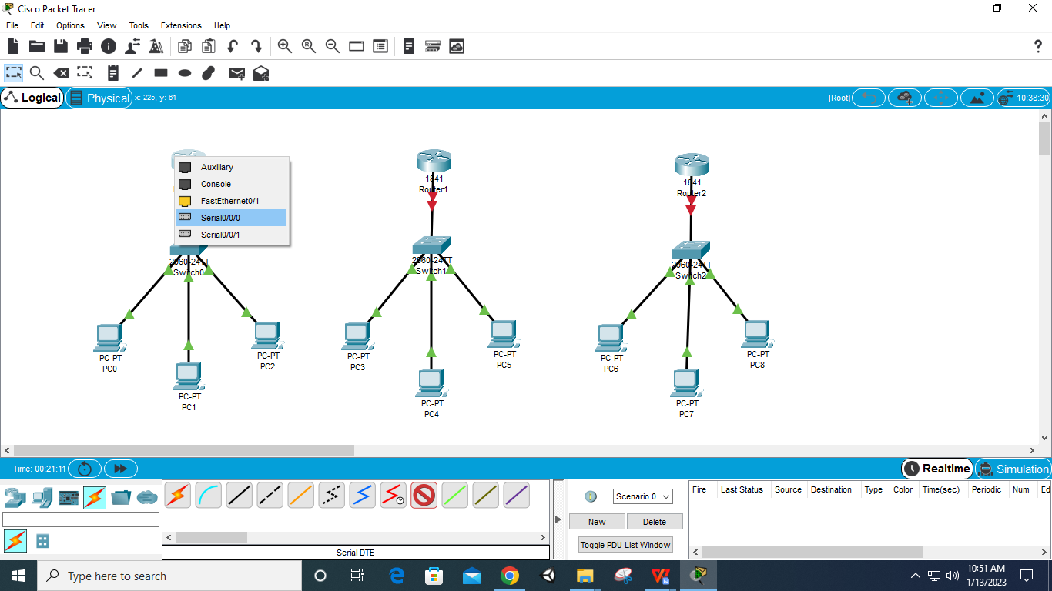

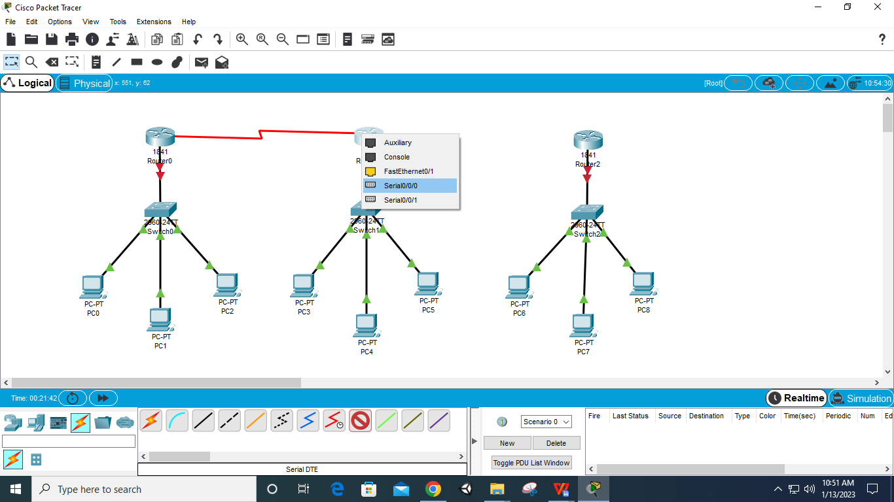

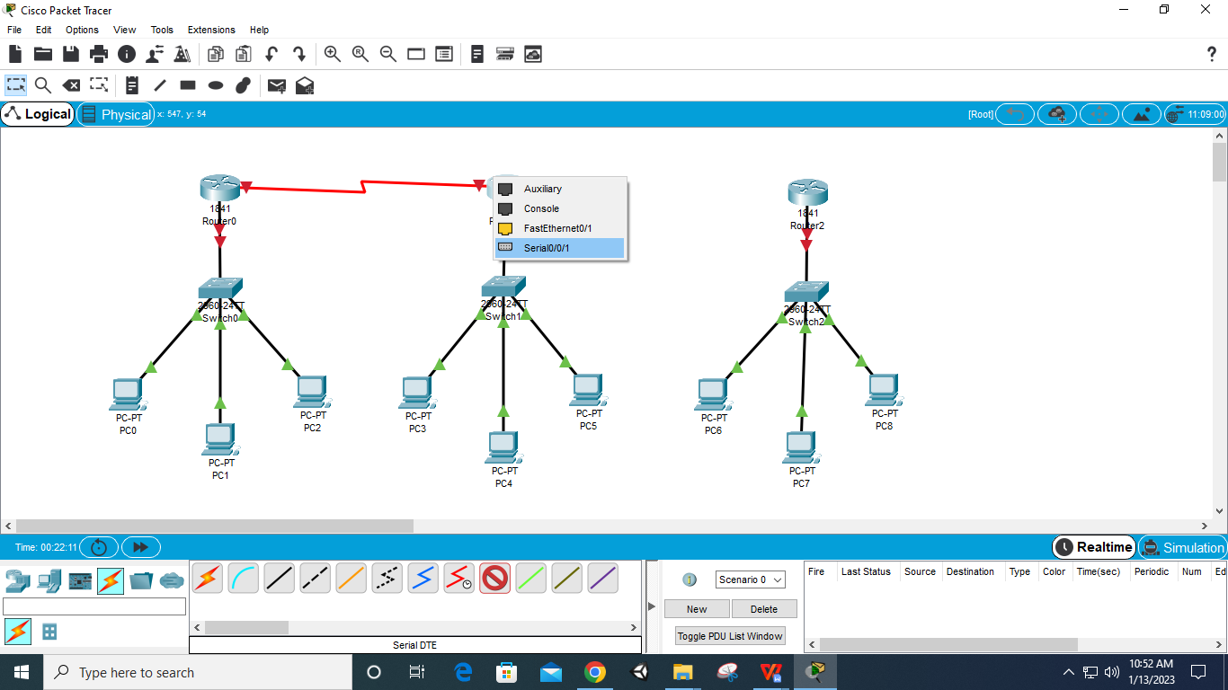

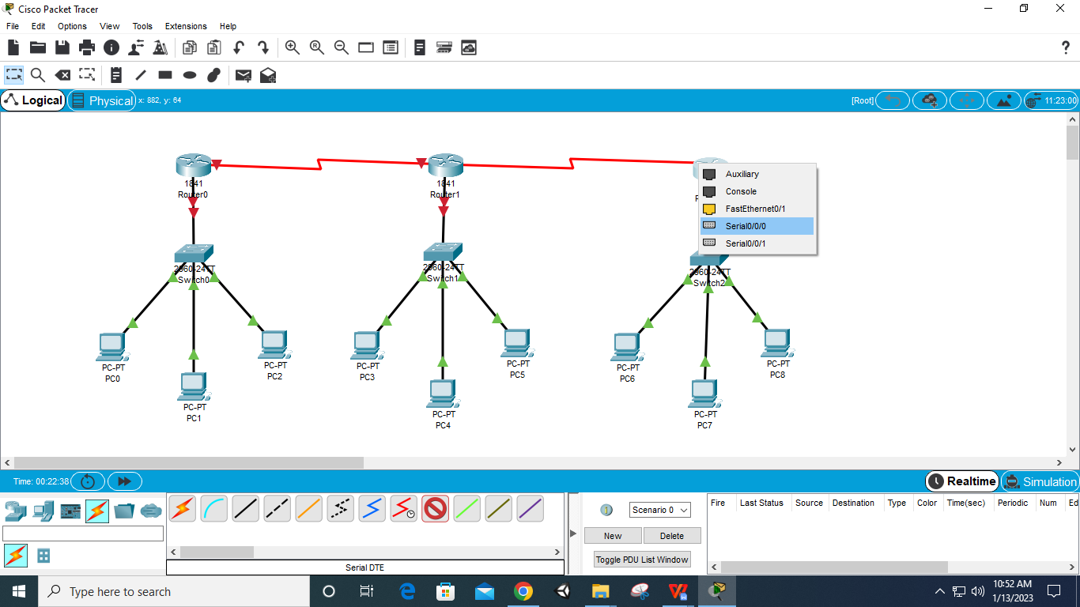

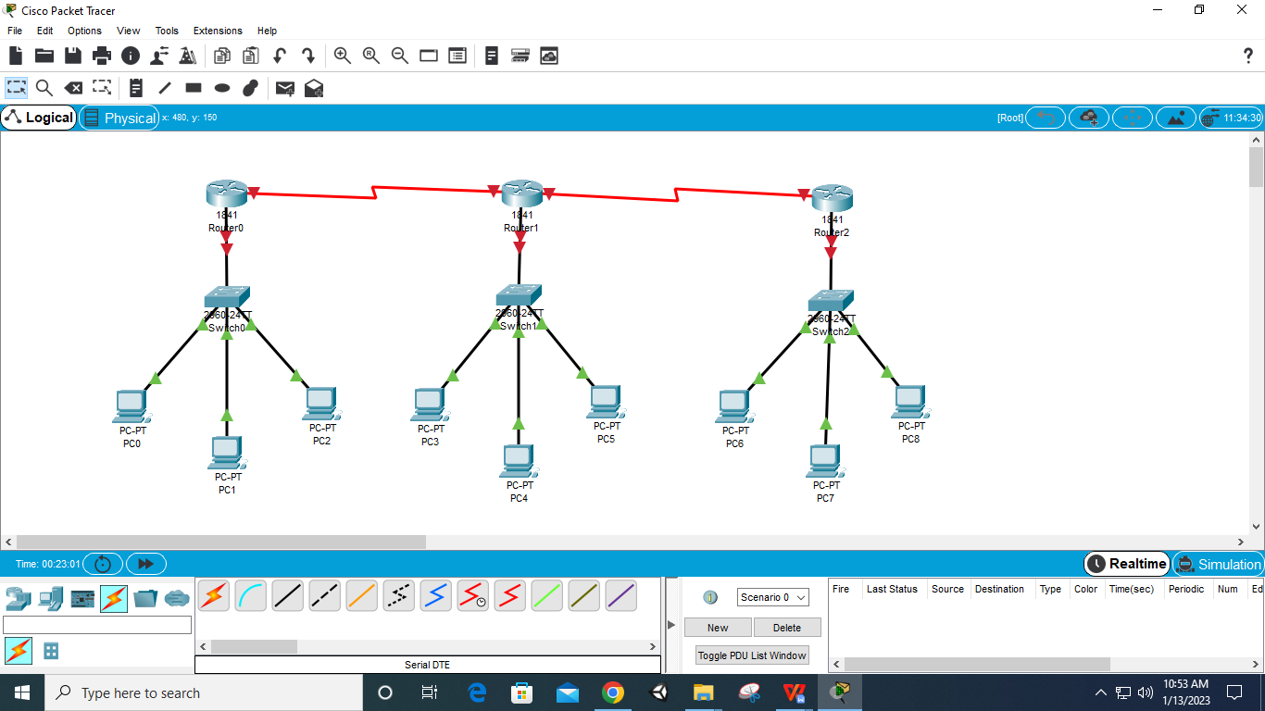

**Step 8: Select first Router – Config – Fastethernet 0/0 – give IP as – 192.168.1.1 – Port Status on**

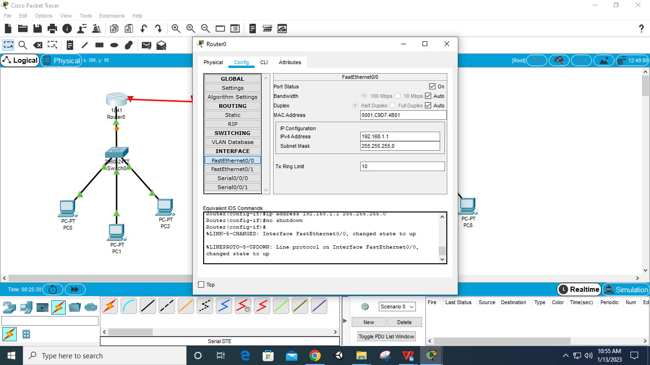

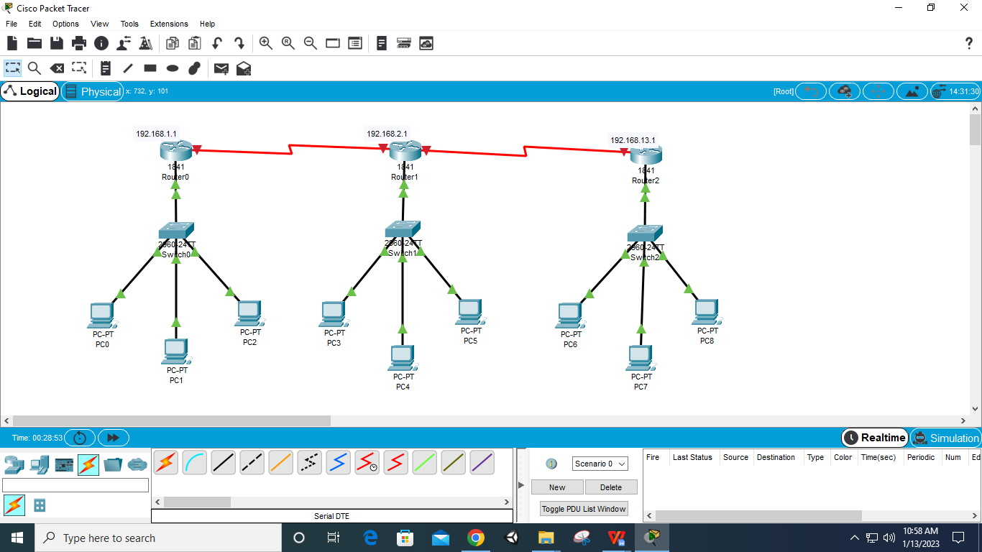

**Step 9: Select PC – Desktop- IP Configuration – IP – 192.168.1.2/.3/.4 & Default Gateway – 192.168.1.1/2/3(Router IP) (for all 9 PCs according to their Routers)**

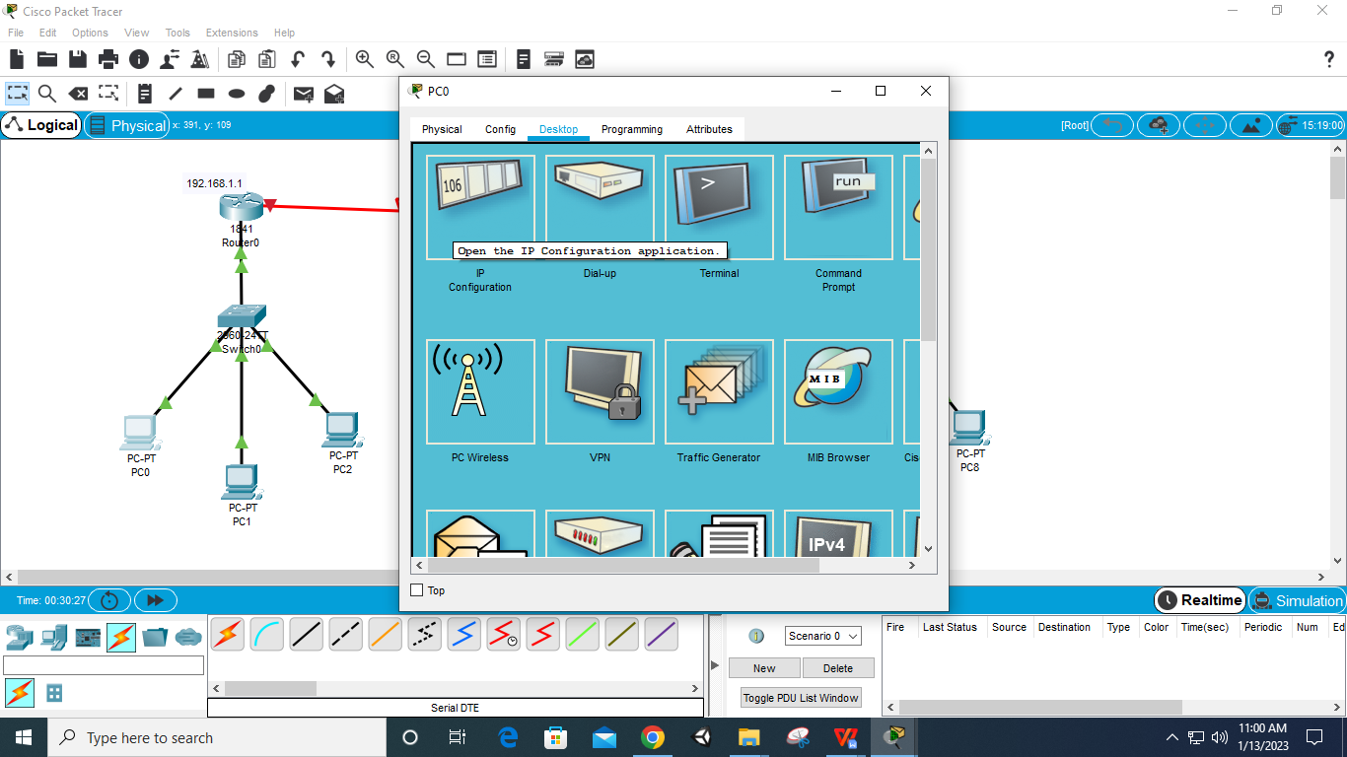

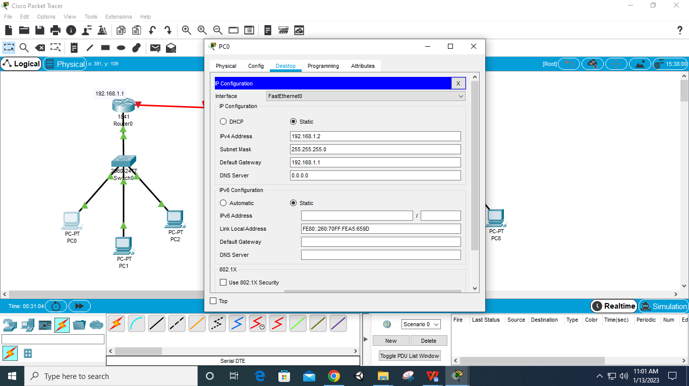

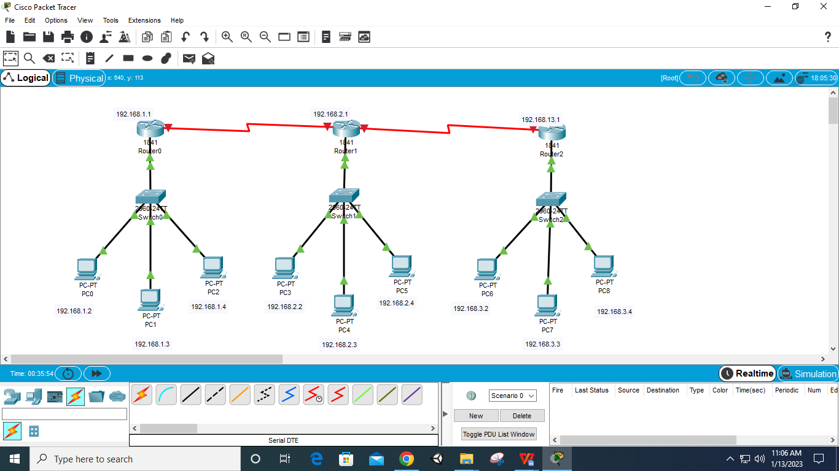

**Step 10: Select first Router – Config – Serial 0/0/0 – set IP – 10.0.0.1 – on the Port**

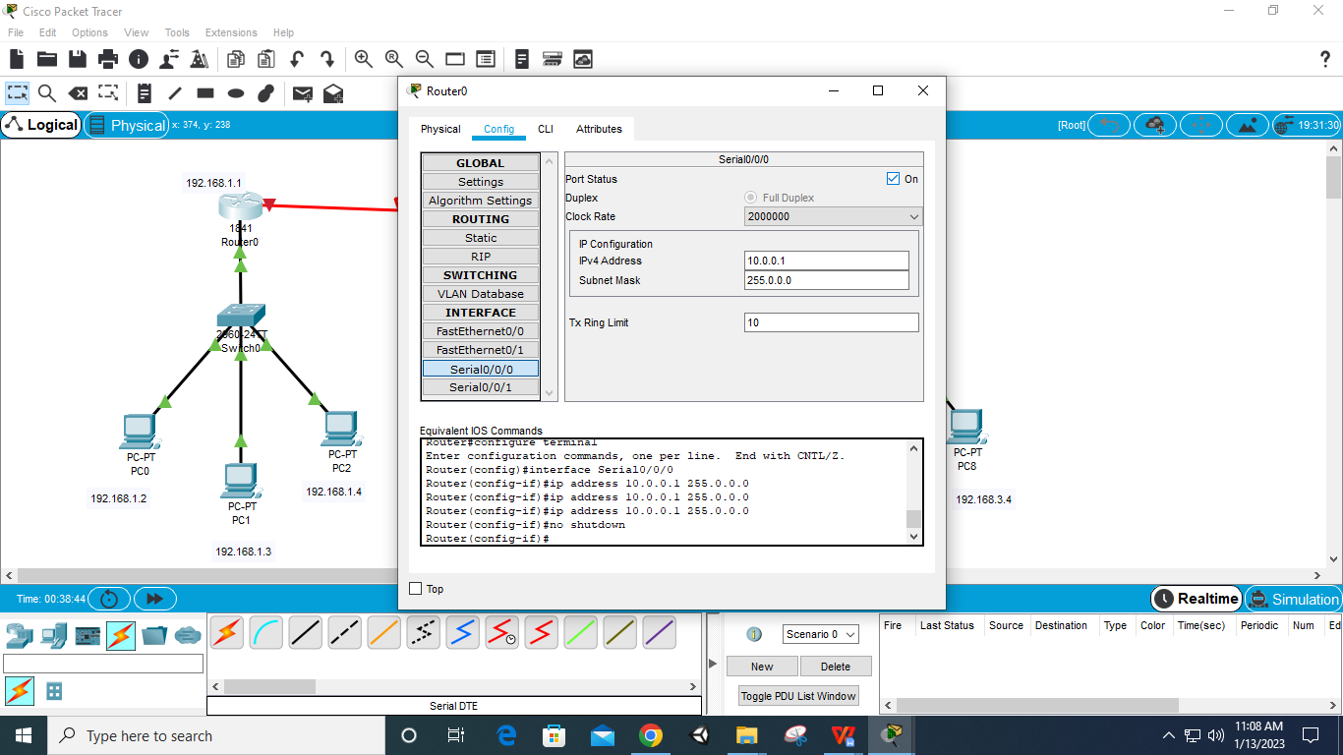

**Step 11: Select second Router – Config – Serial 0 0/0 – set IP – 10.0.0.2 – on the Port**

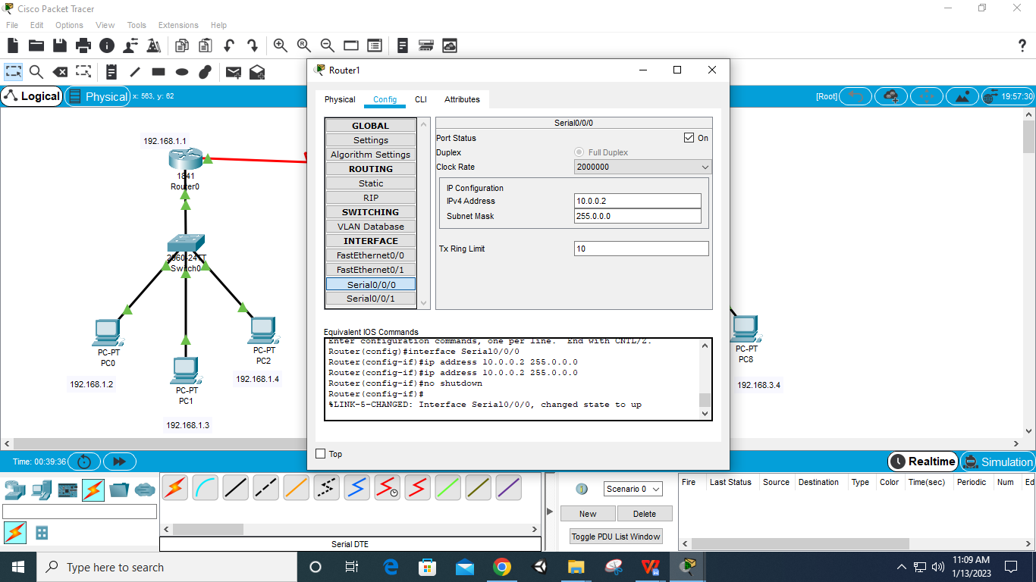

**Step 12: Select second Router – Config – Serial 0/0/1 – set IP – 11.0.0.1 – on the Port**

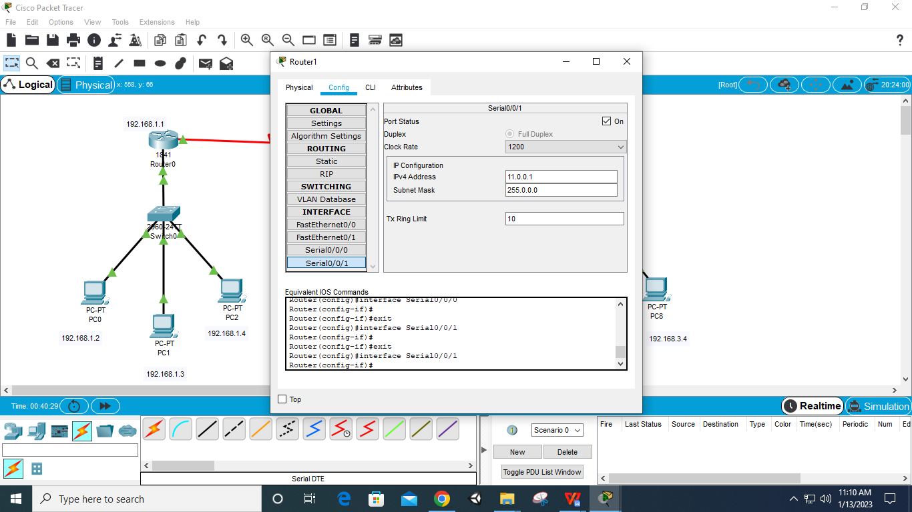

**Step 13: Select third Router – Config – Serial 0/0/0 – set IP – 11.0.0.2 – on the Port**

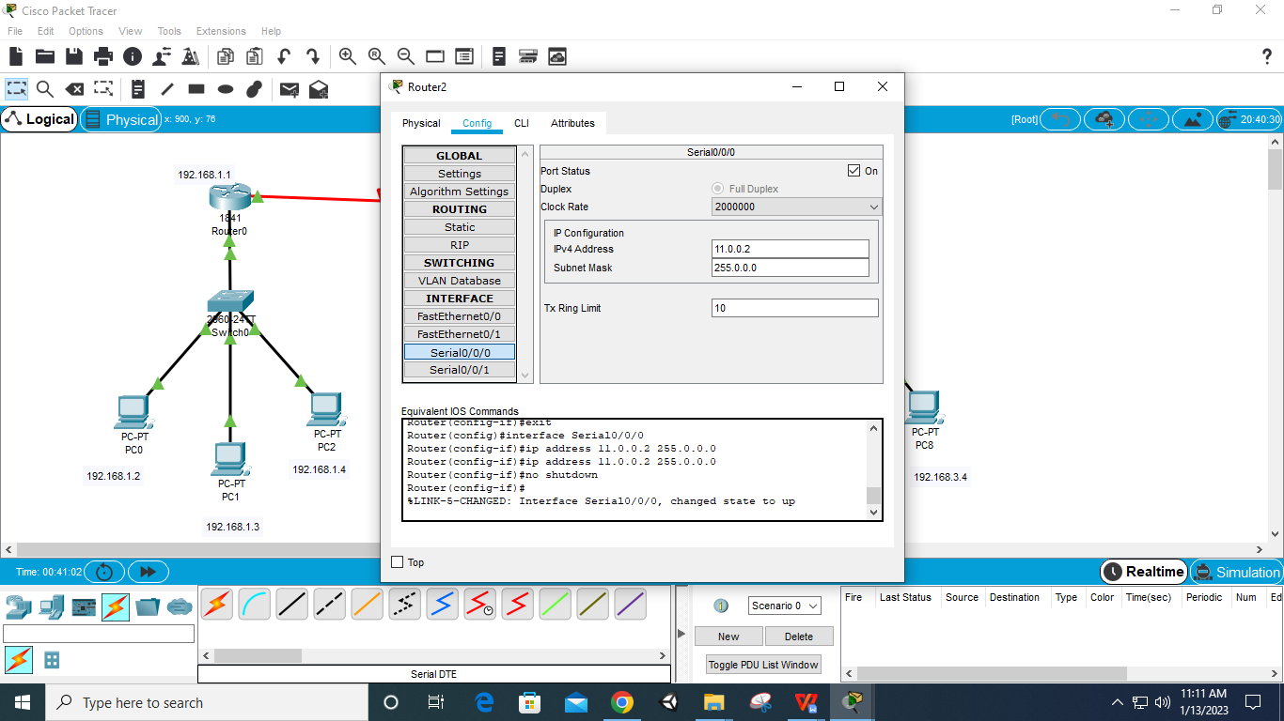

**Step 14: Select first router – config – RIP – Network – add 192.168.1.0, add 192.168.2.0, add 192.168.3.0, add 10.0.0.0 and add 11.0.0.0 (for all 3 Routers)**

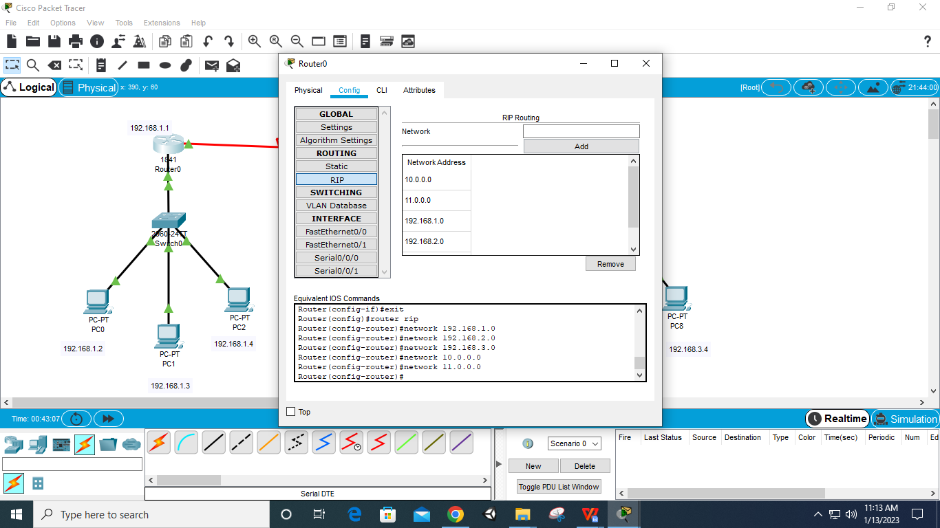

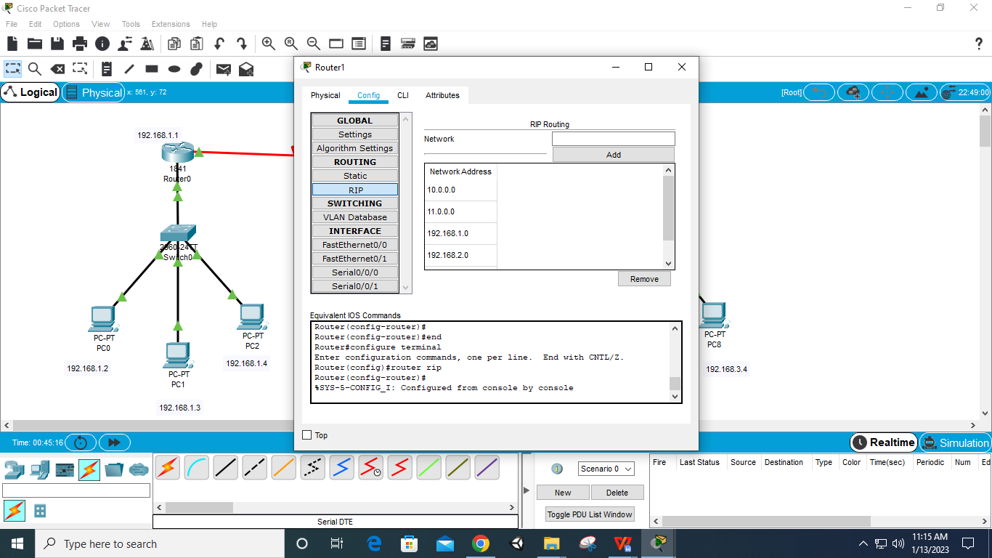

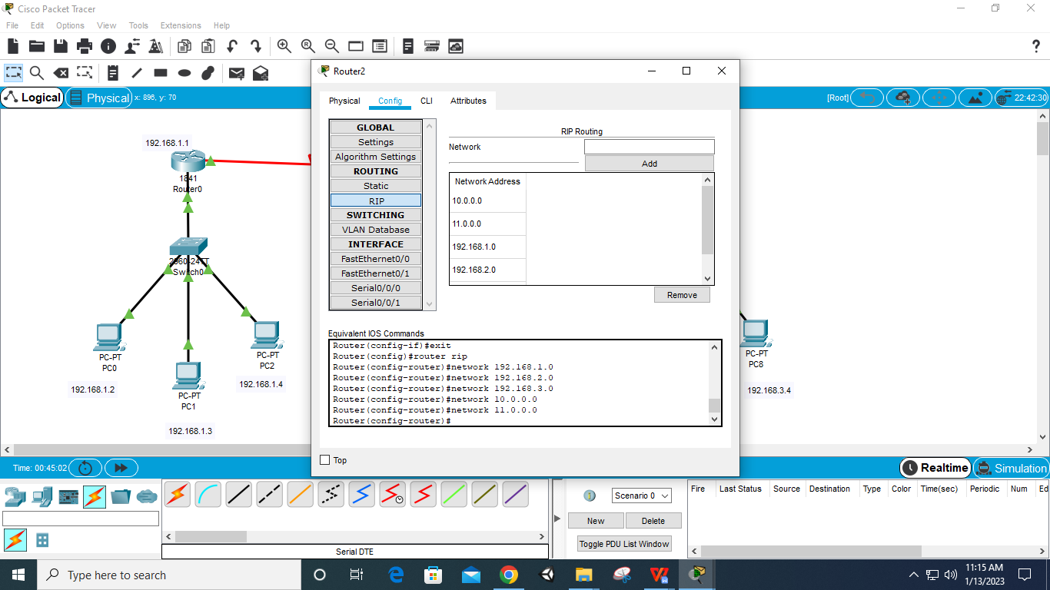

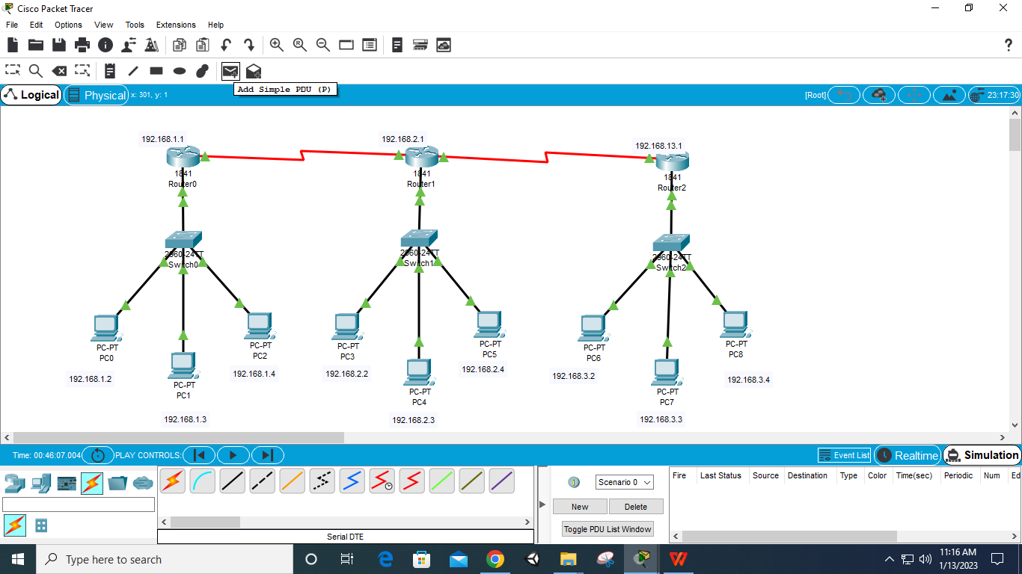

**Step 15: Add Packets and Run Simulation**

